IBM FAST ETHERNET WORKGROUP SWITCH 8275
MODELS 318, 322, 324, AND 326
RELEASE NOTES FOR SOFTWARE VERSION 2.10

The following information describes the functions provided by Software Version 2.10 for the IBM Fast Ethernet Workgroup Switch 8275 Model 324 and Models 318, 322, and 326.

Software Version 2.10 is available on the IBM Networking Technical Support Web site at:

http://www.networking.ibm.com/support

IBM FAST ETHERNET WORKGROUP SWITCH 8275
MODEL 324

Please use the following information in conjunction with the IBM Fast Ethernet Desktop Switch 8275 Model 324 Installation and Planning Guide.

Software Version 2.10 will provide the following functions for the IBM Fast Ethernet Desktop Switch 8275 Model 324.

- Provides support for up to 31 VLANs.
- Port monitoring
- Ping Utility
______________________________________________________________________________________

The following change is made on pages 4-28, 4-29, 5-22, and 5-23 of the IBM Fast Ethernet Desktop Switch 8275 Model 324 Installation and Planning Guide.

The 8275 supports up to 31 VLANs Only 7 VLANs were supported prior to Software Version 2.10.

The following note is added to pages 4-34 and 5-24 of the Installation and Planning Guide:

Note: The 8275 Model 324 supports port trunking to the 8275-2xx series of Ethernet Workgroup switches. The 8275 Model 324 is compatible with SunTrunking™ and Fast EtherChannel® to facilitate large bandwidth connections to other networking devices that are compatible with these standards such as the IBM Netfinity® 10/100 Ethernet Adapters.

IBM FAST ETHERNET WORKGROUP SWITCH 8275
MODELS 318, 322, AND 326

Use the following information in conjunction with the IBM Fast Ethernet Workgroup Switch 8275 Models 318, 322, and 326 Installation and Planning Guide.

Software Version 2.10 provides the following functions for the IBM Fast Ethernet Workgroup Switch 8275 Models 318, 322, and 326.

1. Provides support for up to 31 VLANs.
- Provides support for gigabit uplink.
- Provides gigabit flow control.

______________________________________________________________________________________

The following panel replaces the panel shown on page 4-16 of the IBM Fast Ethernet Workgroup Switch 8275 Models 318, 322, and 326 Installation and Planning Guide.

IBM Fast Ethernet Workgroup Switch, 8275-326
- Device Configuration -

Switch Configuration

Port Configuration

Port Statistics

Spanning Tree Configuration

Serial Port Configuration

VLAN Port Management

Trunking Port Management

Port Monitoring

Gigabit Flow Control

EXIT MAIN MENU HELP

Figure 4-9. Device Configuration Menu

Gigabit Flow Control When a certain threshold of packets received has been surpassed, if the Gigabit Flow Control function is enabled, the switch sends out a pause packet that causes nodes to pause transmissions to this switch.

The Gigabit Flow Control panel is new in software Version 2.10.

IBM Fast Ethernet Workgroup Switch, 8275-326
- Gigabit Flow Control -

Gigabit Port: Flow Control: Pause Transmitted: Pause Received:
3.1 <Enable > 0 0

4.1 <Enable > 0 0

SAVE EXIT MAIN MENU HELP

To enable Gigabit Flow Control on a port do the following steps:

Step 1: Set the flow control option to Enable.

Step 2: Select SAVE and press Enter.

Gigabit Port Module and port # of module/port currently being configured.

Flow Control Choose to either Enable or Disable the packet flow control. The default setting is Enable.

Pause Transmitted Count of how many pauses were sent out because this unit needs more time to process received data.

Pause Received Count of how many pauses were received because another unit needs more time to process received
data.

The following note is added to pages 4-17 and 5-11 of the IBM Fast Ethernet Workgroup Switch 8275 Models 318, 322, and 326 Installation and Planning Guide.

Note: When the gigabit module is inserted, Cut-Through mode is not an option and the Rate Control will automatically be set to Store & Forward.
If you select the Port Statistics option and a gigabit port, the Port Statistics panel will be displayed. If you select any of the other ports, the Port Statistic panel on page 4-22 of the IBM Fast Ethernet Workgroup Switch 8275 Models 318, 322, and 326 Installation and Planning Guide is displayed.

IBM Fast Ethernet Workgroup Switch, 8275-326
- Port Statistics -
Port Number: [3.1 ]
Tx_TotalBytes : 0 Rx_Uni_Frame : 0
Tx_Uni_Frame : 0 Rx_Mult_Frame : 0
Tx_Mult_Frame : 0 Rx_Broad_Frame : 0
Tx_Broad_Frame : 0 Rx_Good_Oversize : 0
Tx_Aged_Frame : 0 Rx_Err_Oversize : 0
Tx_64_Bytes_Frame: 0 Rx_Good_Undersize: 0
Tx_65_to_127 : 0 Rx_Err_Undersize : 0
Tx_128_to_255 : 0 Rx_64_Bytes_Frame: 0
Tx_256_to_511 : 0 Rx_65_to_127 : 0
Tx_512_to_1023 : 0 Rx_128_to_255 : 0
Tx_1024_to_1518 : 0 Rx_256_to_511 : 0
Tx_Oversize : 0 Rx_512_to_1023 : 0
Rx_TotalBytes : 0 Rx_1024_to_1518 : 0
Rx_Disc_Overrun : 0 Rx_Drop_Mem_Full : 0
Rx_Sync_Loss_Err : 0 Rx_FIFO_Full_Err : 0
Rx_CRC_Err : 0 Rx_Drop_EXEOF : 0
Rx_Symbol_Err : 0 Rx_Drop_Threshold: 0
Rx_Seq_Dlmtr_Err : 0
EXIT MAIN MENU HELP

Tx_TotalBytes | Total number of bytes transmitted to the port.
Tx_Uni_frame | Number of unicast frames transmitted.
Tx_Mult_frame | Number of multicast frames transmitted.
Tx_Broad_frame | Number of broadcast frames transmitted.
Tx_Aged_frame | Number of frames that were dropped because they experienced too long a transit time.
Tx_64_Bytes_Frame | Number of frames transmitted that were 64 bytes in length.
Tx_65_to_127 | Number of frames transmitted that were 64 to 127 bytes in length.
Tx_128_to_255 | Number of frames transmitted that were 128 to 255 bytes in length.
Tx_256_to_511 | Number of frames that were 256 to 511 bytes in length.
Tx_512_to_1023 | Number of frames transmitted that were 512 to 1023 bytes in length.
Tx_1024_to_1518 | Number of frames transmitted that were 1024 to 1518 bytes in length.
Tx_Oversize | Number of oversize frames transmitted that were greater than 1518 bytes in length.
Rx_TotalBytes | Total number of frames received.
Rx_Disc_Overrun | Number of frames that were discarded because of receive overrun.
Rx_Sync_Loss_Err | Number of frames received with sync loss error.
Rx_CRC_Err | Number of frames that were received with CRC error.
Rx_Symbol_Err | Number of frames that were received with one or more symbol errors.
Rx_Seq_Dlmtr_Err | Number of frames that were received with sequence delimiter error.
Rx_Uni_frame | Number of unicast frames received
Rx_Mult_frame | Number of multicast frames received.
Rx_Broad_frame | Number of broadcast frames received.
Rx_Good_Oversize | Number of good frames received that were greater than 1518 bytes in length.
Rx_Err_Oversize | Number of errored frames received that were greater than 1518 bytes in length.
Rx_Good_Undersize | Number of good frames that were less than 64 bytes in length.
Rx_Err_Undersize | Number of errored frames that were less than 64 bytes in length.
Rx_64_Bytes_Frame | Number of frames received, including errors, that were 64 bytes in length
Rx_65_to_127 | Number of frames received, including frames with errors, that were 65 to 127 bytes in length.
Rx_128_to_255 | Number of frames received, including frames with errors, that were 128 to 255 bytes in length.
Rx_256_to_511 | Number of frames received, including frames with errors, that were 256 to 511 bytes in length.
Rx_512_to_1023 | Number of frames received, including frames with errors, that were 512 to 1023 bytes in length.
Rx_1024_to_1518 | Number of frames received, including frames with errors, that were 1024 to 1518 bytes in length.
Rx_Drop_Mem_Full | Number of frames that were dropped because of a memory-full condition.
Rx_FIFO_Mem_Full | Number of frames received with FIFO-full error.
Rx_Drop_EXEOF | Number of frames dropped due to GGI protocol error as indicated in RXEOF.
Rx_Drop_Threshold | Number of frames dropped because of threshold limit.

If your model has the gigabit module installed in slots 3 or 4, or both, the following changes apply to pages 4-19 and 4-20 of the IBM Fast Ethernet Workgroup Switch 8275 Models 318, 322, and 326 Installation and Planning Guide. The slot number and port numbers appear on the final Port Configuration panel as ports 3.1 and 4.1 as shown in the figure below.

IBM Fast Ethernet Workgroup Switch, 8275-326
- Port Configuration -

Link STP STP
Port: State: Physical: Status: Priority: Port State: Module:
3.1 <Enable > <1000SX/Full> Link Down [128] Forwarding 1SX

4.1 <Enable > <1000SX/Full> Link Down [128] Forwarding 1SX

PREV NEXT SAVE EXIT MAIN MENU HELP

The following definitions are added to pages 4-20, 5-14, and 5-15 of the IBM Fast Ethernet Workgroup Switch 8275 Models 318, 322, and 326 Installation and Planning Guide.

Physical For Gigabit ports the available physical layer interface can be Auto or 1000SX/Full Mode. In the Auto Mode, the port auto-negotiates flow control capability and can only work with a link partner that is also in Auto Mode. In the forced or 1000SX/Full Mode, you should ensure that both ends have the same setting for flow control. The default setting is Auto.

Link Status 1000SX/Full Link is connected at 1000 Mbps/full duplex.

The following text change is made on pages 4-29 and 5-22 of the IBM Fast Ethernet Workgroup Switch 8275 Models 318, 322, and 326 Installation and Planning Guide.

The 8275 supports up to 31 VLANs. Only 7 VLANS were supported prior to Software Version 2.10.

The following note is added to pages 4-34 and 5-24 of the IBM Fast Ethernet Workgroup Switch 8275 Models 318, 322, and 326 Installation and Planning Guide.

Note: The 8275 Models 318,322, 326 support port trunking to the 8275-2xx series of Ethernet Workgroup switches. The 8275 Models 318,322, 326 are compatible with SunTrunking™ and Fast EtherChannel® to facilitate large bandwidth connections to other networking devices that are compatible with these standards such as the IBM Netfinity® 10/100 Ethernet Adapters.

The following note is added to page 5-13 of the IBM Fast Ethernet Workgroup Switch 8275 Models 318, 322, and 326 Installation and Planning Guide:

Note: If your model has the gigabit module installed in slots 3 or 4, or both, then the slot number and port numbers of the gigabit uplink appear when you scroll to the end of the port configuration panel and appear as 3.1 and/or 4.1.

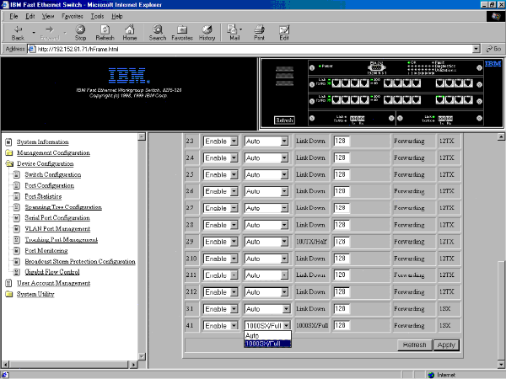

On the web interface, if you select the Port Statistics option and a gigabit port, the following Port Statistics panel is displayed. If you select any of the other ports, the Port Statistic panel on page 5-16 of the IBM Fast Ethernet Workgroup Switch 8275 Models 318, 322, and 326 Installation and Planning Guide is displayed.

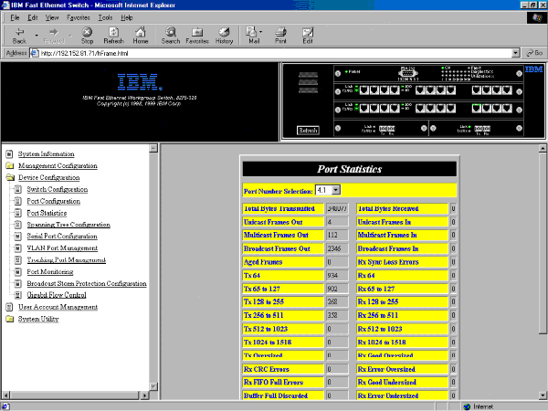

Tx_TotalBytes | Total number of bytes transmitted to the port.
Tx_Uni_frame | Number of unicast frames transmitted.
Tx_Mult_frame | Number of multicast frames transmitted.
Tx_Broad_frame | Number of broadcast frames transmitted.
Tx_Aged_frame | Number of frames that were dropped because they experienced too long a transit time.
Tx_64_Bytes_Frame | Number of frames transmitted that were 64 bytes in length.
Tx_65_to_127 | Number of frames transmitted that were 64 to 127 bytes in length.
Tx_128_to_255 | Number of frames transmitted that were 128 to 255 bytes in length.
Tx_256_to_511 | Number of frames that were 256 to 511 bytes in length.
Tx_512_to_1023 | Number of frames transmitted that were 512 to 1023 bytes in length.
Tx_1024_to_1518 | Number of frames transmitted that were 1024 to 1518 bytes in length.
Tx_Oversize | Number of oversize frames transmitted that were greater than 1518 bytes in length.
Rx_TotalBytes | Total number of frames received.
Rx_Disc_Overrun | Number of frames that were discarded because of receive overrun.
Rx_Sync_Loss_Err | Number of frames received with sync loss error.
Rx_CRC_Err | Number of frames that were received with CRC error.
Rx_Symbol_Err | Number of frames that were received with one or more symbol errors.
Rx_Seq_Dlmtr_Err | Number of frames that were received with sequence delimiter error.
Rx_Uni_frame | Number of unicast frames received
Rx_Mult_frame | Number of multicast frames received.
Rx_Broad_frame | Number of broadcast frames received.
Rx_Good_Oversize | Number of good frames received that were greater than 1518 bytes in length.
Rx_Err_Oversize | Number of errored frames received that were greater than 1518 bytes in length.
Rx_Good_Undersize | Number of good frames that were less than 64 bytes in length.
Rx_Err_Undersize | Number of errored frames that were less than 64 bytes in length.
Rx_64_Bytes_Frame | Number of frames received, including errors, that were 64 bytes in length
Rx_65_to_127 | Number of frames received, including frames with errors, that were 65 to 127 bytes in length.
Rx_128_to_255 | Number of frames received, including frames with errors, that were 128 to 255 bytes in length.
Rx_256_to_511 | Number of frames received, including frames with errors, that were 256 to 511 bytes in length.
Rx_512_to_1023 | Number of frames received, including frames with errors, that were 512 to 1023 bytes in length.
Rx_1024_to_1518 | Number of frames received, including frames with errors, that were 1024 to 1518 bytes in length.
Rx_Drop_Mem_Full | Number of frames that were dropped because of a memory-full condition.
Rx_FIFO_Mem_Full | Number of frames received with FIFO-full error.
Rx_Drop_EXEOF | Number of frames dropped due to GGI protocol error as indicated in RXEOF.
Rx_Drop_Threshold | Number of frames dropped because of threshold limit.

The Gigabit Flow Control Panel is new in Software Version 2.10.

Gigabit Flow Control

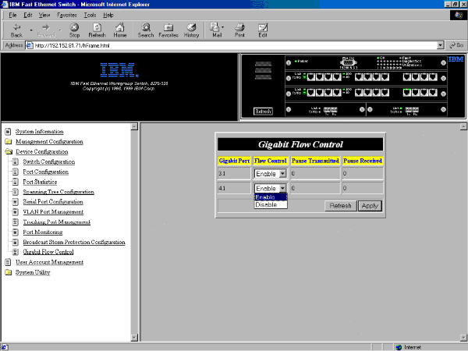

When a certain threshold of packets received has been surpassed, when the gigabit flow control function is enabled, the switch sends out a pulse packet which causes outside nodes to pause transmissions to this switch.

Gigabit Port Module and port number of module/port currently being configured.

Flow Control Choose to either Enable or Disable the packet flow control. The default setting is Enable.

Pause Transmitted Count of how many pauses were sent out because this unit needs more time to process received data.

Pause Received Count of how many pauses were received because
another unit needs more time to process received data.

